Instituto Federal de Mato Grosso do Sul

Aluno: Luan Freire Alves da Silva

Turma: 2020

Professor: Alisson Gaspar Chiquitto

**Atividade de Internet das coisas**

***Circuito 7493***

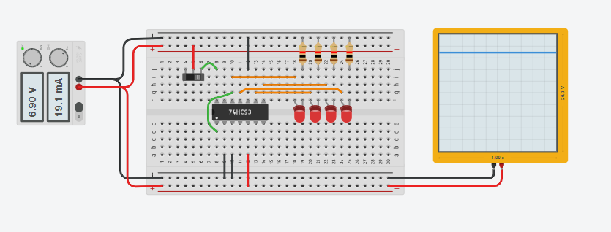

*Link:* [*https://www.tinkercad.com/things/8UYu9ClWZnk-cool-hillar-kasi/editel?sharecode=WT4gJk8i0WO1bp766MIi3CbJ933Wjm7QX1B7xGcRZ1A*](https://www.tinkercad.com/things/8UYu9ClWZnk-cool-hillar-kasi/editel?sharecode=WT4gJk8i0WO1bp766MIi3CbJ933Wjm7QX1B7xGcRZ1A)